**Learning objectives:**

* Learn what git and github are
* Create an account
* Learn to clone a repository
* Learn to upload code to github
* Learn to initialize a repository
* Learn how to write a README file (markdown)

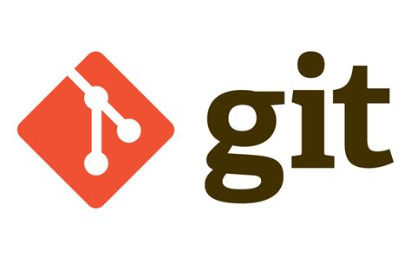

# What is Git?

A **distributed version control system**.

A version control system keeps a history of changes made to a file so you can revert to an earlier version if needed. Git works by storing files in **repositories** which also contain the history of changes.

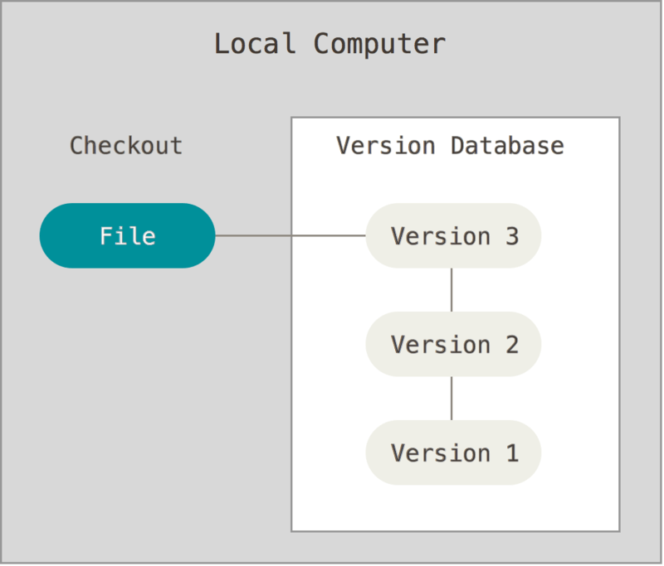

From Git’s website

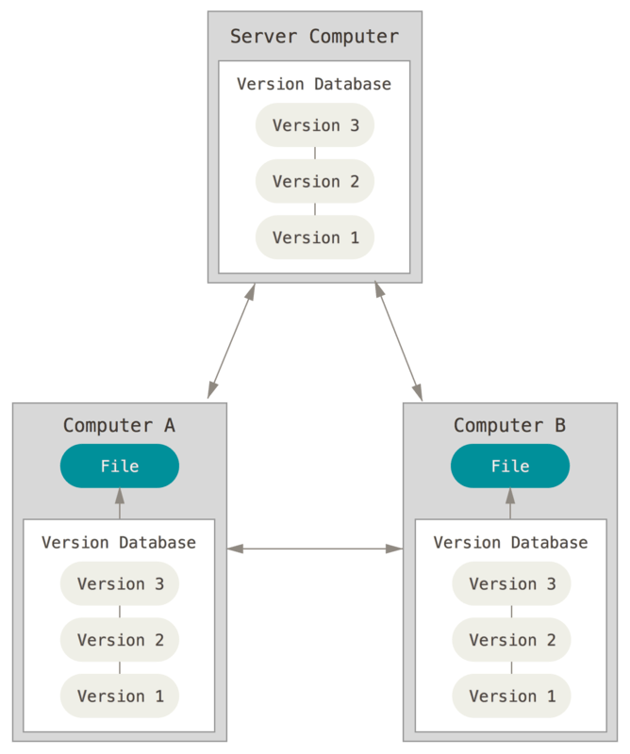Git is a *distributed* version control system, which means that each user can have a complete copy of the repository on their machine, including the history. When the user wants to update a remote repository with the changes they have made, they can **push** the changes from their local copy to the remote repository.

From Git’s website

# What is GitHub?

A web-hosting service for Git repositories. It is used by developers to collaborate on large scale projects and by scientists to share and obtain data and code.

# Why use Git/GitHub

1. Efficient way to version control.
2. You may need to be able to access data or code shared on GitHub.
3. It is a good way to share your own data and code or any other files (I’ve seen books on github)

# Terminology

**Clone:** Creating a copy of a repository on your computer.

**Commit:** “Saving” the changes made to a repository. You can go back to a previously committed version in the future.

**Push:** Updating a remote repository with the changes made to your local copy of the repository.

From Kendra Oudyk’s Git workshop

# How to create a GitHub account

1. Go to <https://github.com/>
2. Click on sign up
3. Follow the instructions

Note 1: Student can get access to services such as an AI code assistant for free by applying for GitHub education

Note 2: We can create an “organization” on GitHub for our lab.

# Options to use Git

There are several options to use Git, including the terminal (Git Bash), various graphical user interfaces (GitHub desktop for example), hosting services (such as GitHub), and through coding platforms (like visual studio code). This guide will focus on GitHub desktop.

# GitHub Desktop

## Installation

<https://desktop.github.com/download/>

## Cloning a repository

1. Search the GitHub repository you want to clone online.
2. Once you are on the main page of the repository, click on the green “code” button and copy the url.
3. Open GitHub desktop. Click on file > clone repository… > URL and paste the URL you copied in step 2.
4. Specify where you want the repository to be stored on your computer in the “Local path” box.

## Commit changes made to a repository

1. Navigate to the repository on GitHub desktop by clicking on “current repository” on the left and choosing the desired repository.
2. Write a commit summary and click on the commit button on the lower left. You most likely will work on the main branch so the button will say “commit to main”.

Note: You can use the left navigation bar to navigate to different files in your repository. You will be able to see the history of changes for each file.

## Push changes

1. Click on push origin on the top of the page. Origin is the name given to the remote repository from which the data was cloned

Note: You will only be able to push changes if you have made and *committed* changes in your local copy of the repository.

## Creating a new repository

1. Click on file > New repository…

## Writing a README

If you make your repository public. It will be a good idea to write a README file. The README file is used to give people who visit your repository important information such as what data is stored there, how to use the code hosted in the repository, links to other websites or information on how to cite.

The README file is written using markdown, a popular markup language. Here is an example of how it works.

# Exercises

Paired exercise:

* + Person 1:
    - Initialize a repository
    - Write a README file
  + Person 2:
    - Clone the repository
    - Modify it
    - Push the changes
  + Try to switch roles!

Optional: try the previous activities using Git bash.

Optional: create a github pages website: <https://pages.github.com/>